Traffic Program

Details about the Traffic Program

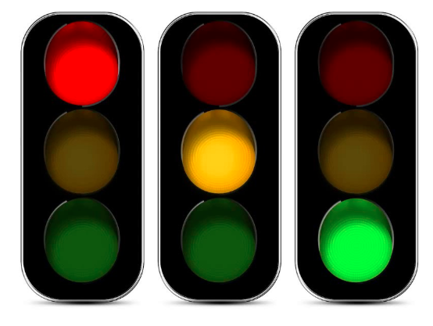

**MAST**

ITSP Project

# 

# INTRODUCTION

It is the main part of the whole project. It handles all the values provided by the ML Program to manage the traffic lights. It also handles the way on how to manage the emergency vehicles.

# HYPOTHESIS

We have made a basic algorithm that has a flowchart like this:

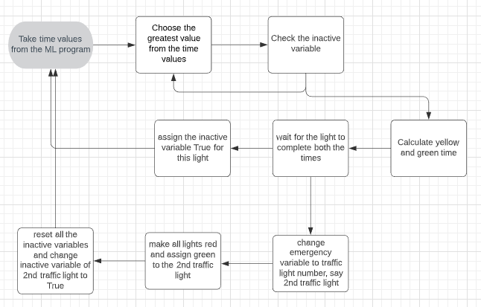It is pretty what we have implemented in the program. Let me explain each step:

1. We take in all the time values of light from the ML program output.
2. We make an inactive variable which contains a boolean value of each light that needs to be False in order to have a colour change. If all lights have the value True, it is reset all to False.
3. Take out the maximum time from the time values, check its inactive variable. If the inactive variable is True, choose the next greatest value and repeat this procedure. Else, continue.
4. Calculate the yellow time via this function;
$yellow light value = max( 2, min( 10 \% of time value, 5))$

5. Assign the green light for this amount of time = time value - yellow light value
6. Assign the yellow light for the ‘yellow light value’ amount of time.
7. Assign the inactive variable True for that light and repeat this whole loop.

#### IN CASE OF EMERGENCIES:

1. It will happen while we are waiting for the red lights. So, whenever that happens a variable, by the name of emergency variable, will change its value from 0 to the number of the traffic light (that will turn green).
2. Assign green to that light.
3. Wait for the signal to be detected at another system and change the emergency variable to 0.
4. Assign red light and change the inactive variable of the light to True.
5. Get back in the loop via updating the values of the time values of light.

# EMERGENCY DETECTION SYSTEM

We are using a simple active RFID circuit, where the receiver is at a distance of 30 metres from the intersection and the emitter will be in the emergency vehicle. The vehicle needs to turn on their part of the circuit to get clear.

We have two options in active RFID: transponding RFID and intelligent RFID.

1. Transponding RFID just identifies whether the vehicle has arrived in the vicinity of the intersection. This is also very battery efficient. In the case of transponders, we will need 4 tags (1 for each road).
2. Intelligent RFID does the same work as the transponder but tracks the location of the signal as well. This will help in tracking the location of emergency vehicles as well. Only one tag will do the work for one intersection.

The intelligent RFIDs serve the purpose in a better way but are also expensive. We will be deciding on this part keeping the budget constraint in mind.

# RESULTS

We haven’t really tested our program in the practical area.

# REFERENCES

1. <https://www.researchgate.net/publication/260833477_Smart_Traffic_Management_System>